In iot side only mode needed is the nodeMCU code

Change ssid = wifi name

Change password to = wifi password

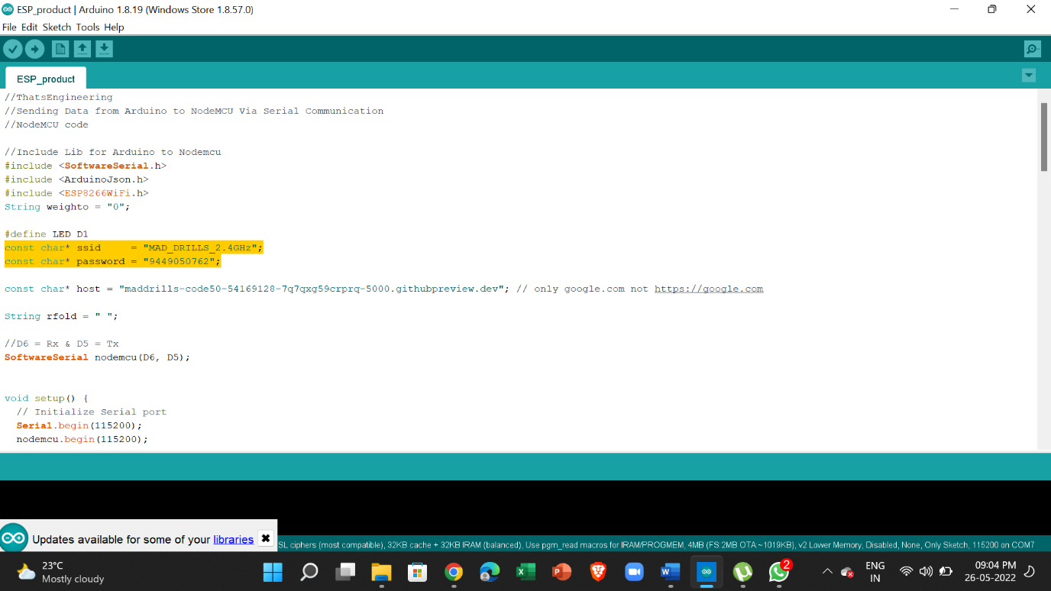

Under host change it to the public port 5000 link

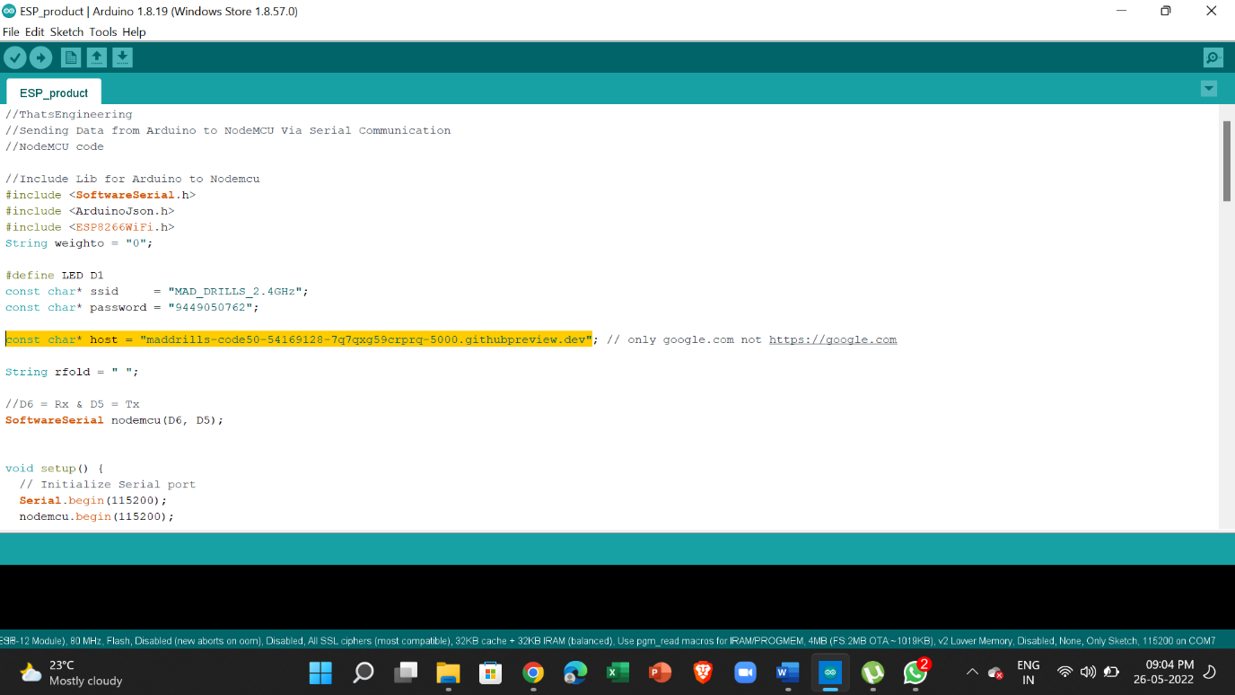

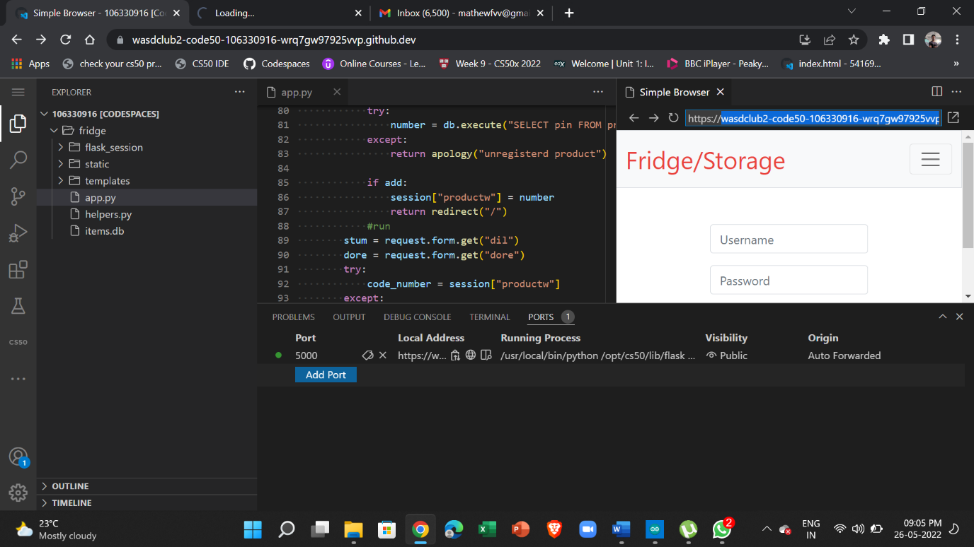

If there is trouble uploading code make sure below libraries are added check lib folder

Also make sure nodeMCU board is added to IDE check youtube

#include <SoftwareSerial.h>

#include <ArduinoJson.h>

#include <ESP8266WiFi.h>